Improving Educational Outcomes in Manufacturing Engineering Technologist and Technician Education (METTE) Programs

Our guiding research questions
- What individual and institutional factors are associated with optimal student outcomes?
- How can key METTE stakeholders use research data and findings to inform strategic program improvement decisions?

Our goal is to
Improve student success in two-year college programs that prepare postsecondary students to enter employment in manufacturing as engineering technicians or transfer to baccalaureate programs in fields related to manufacturing.

We are looking at
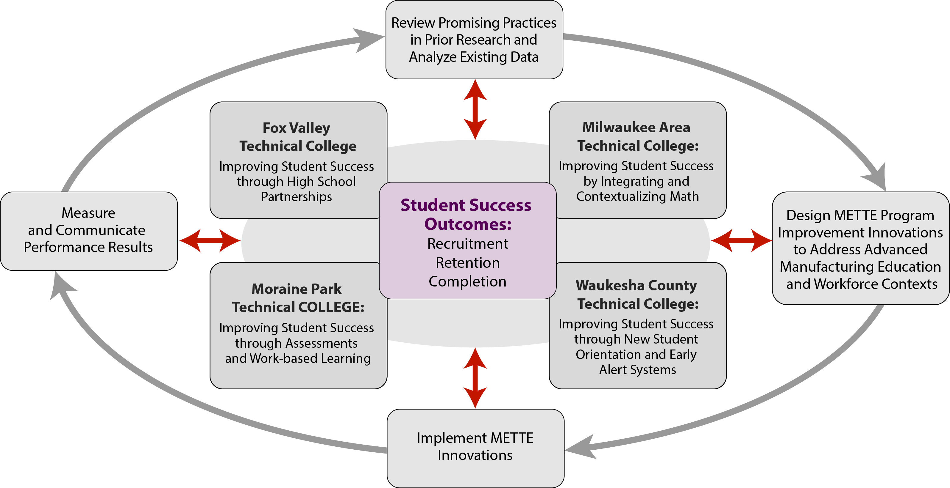

- A baseline cohort of 392,617 students who entered Wisconsin technical colleges between academic year 05-06 and 12-13.
- 4,447 students from the 4 partner technical colleges, including students from oversampled METTE classes & other randomly sampled courses, who completed the CCSSE survey in Spring 2012. Of these, 2,643 students were matched with administrative and transcript data (524 METTE students from 45 programs).
- METTE programs in 4 participating public, 2-year technical colleges in Wisconsin:
Fox Valley Technical College
Milwaukee Area Technical College
Moraine Park Technical College
Waukesha County Technical College
Our model of student success
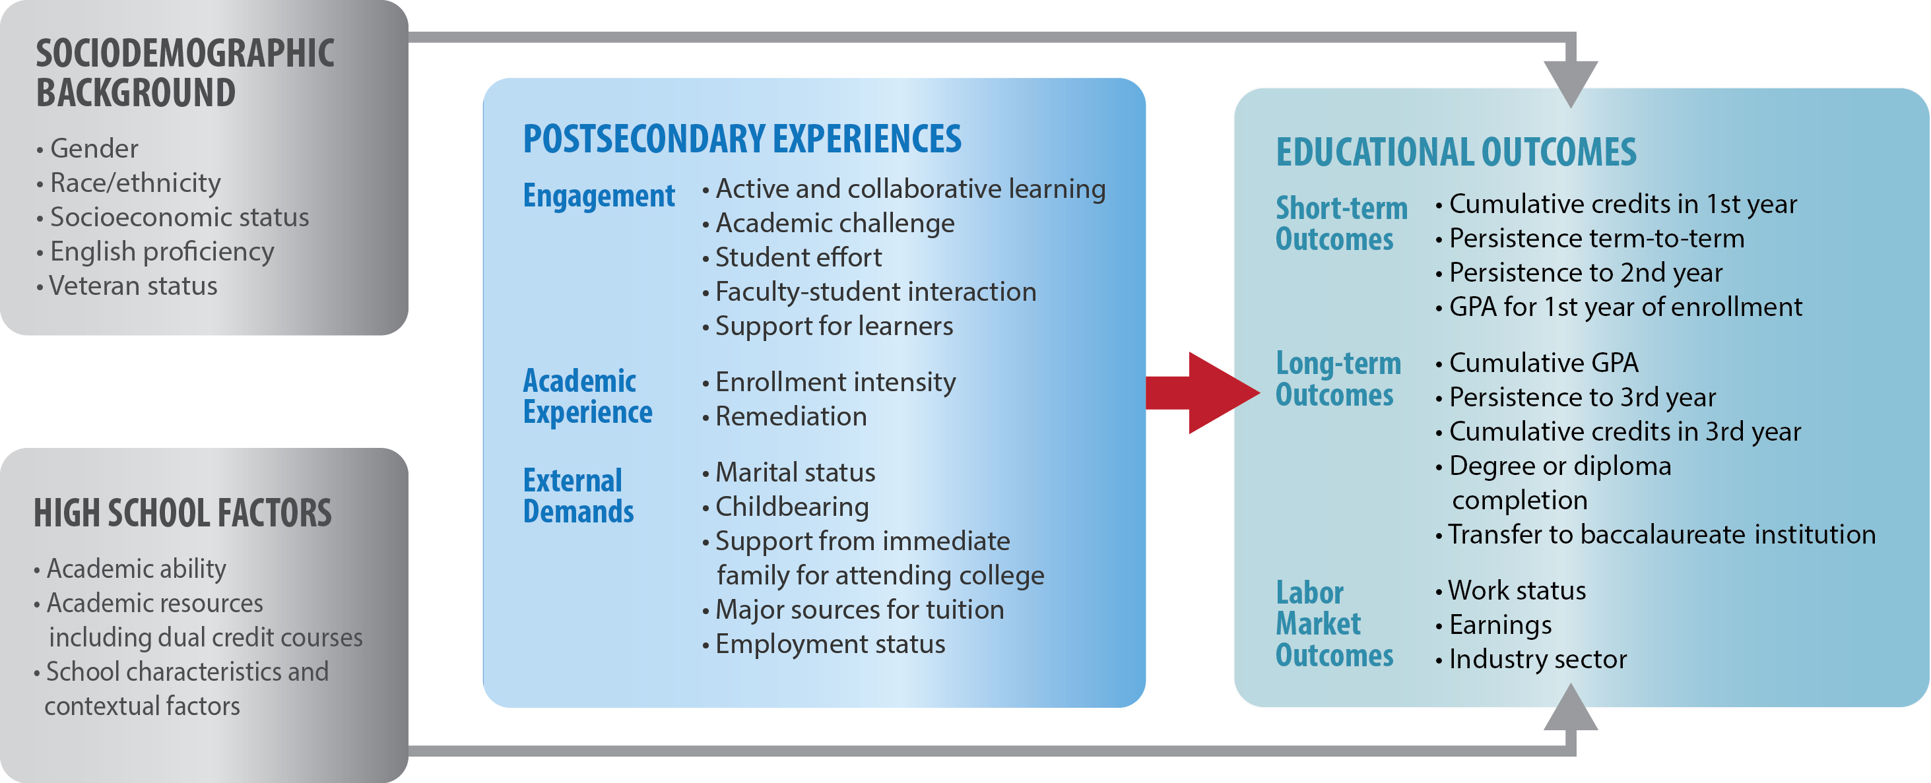


Data we use
- Quantitative data (updated once a year). Our data sharing agreement with the WTCS state office provides a periodically updated data set which employs a stable surrogate student ID number. This ID number informs questions about student progress and outcomes from the following state-level education and labor market data systems:
  - Client Reporting System and Graduate Follow-Up Survey from WTCS
  - National Student Clearinghouse
  - Quarterly Census of Employment and Wages from the Wisconsin Department of Workforce Development
  - Wisconsin Knowledge and Concepts Examination (10th-grade test scores) from the Wisconsin Department of Public Instruction’s Longitudinal Data System
  - Community College Survey of Student Engagement (CCSSE)
  - Survey data collected from students involved with NIC initiatives within the METTE project.

- Qualitative (ongoing)
  - Open-ended text responses from survey data collected from students involved with NIC initiatives within the METTE project.
  - Transcripts from in-depth interviews and focus groups with student, METTE program faculty and other key stakeholders.
  - Agendas and summary notes from the Local Leadership Team and Networked Improvement Community meetings in the 4 partner colleges.

Impact through Networked Improvement Community (NIC)
NIC projects document effective institutional practices, and provide insights to education- and training-related policies and program improvement
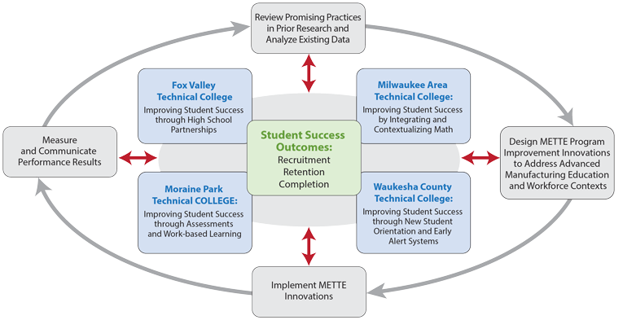

NIC projects
FVTC
  - Using college success data to improve high school partnerships
  - Supporting the Career Jump Start initiative to enhance career readiness

MATC
  - Enhancing math performance with integrated and contextualized math

MPTC
  - Linking students with regional employers to increasing knowledge about regional employment opportunities and the skills needed for success in the regional labor market
  - Using diagnostic placement tests for enhancing student success

WCTC
  - Early alert and warning systems
  - Improving student retention with new student orientation

  - Research to Date

Aspiration & Enrollment in STEM Fields

Students in Manufacturing and Other STEM Fields at Two-Year Colleges: An Exploration of Aspirations and Enrollment (Spring 2012)

From a national sample of 2002 high school graduates, we found:
- Students who described themselves as being in both the academic & occupational tracks in high school were more likely to enroll in manufacturing programs instead of other STEM fields.
- Having at least one advanced placement (AP) math credit in high school was associated with 70.3% (girls) or 25.8% (boys) more likely to aspire to manufacturing fields, and 44.2% (girls) and 7.6% (boys) more likely to actually enroll in manufacturing fields at two-year colleges.
Download the full report at: http://goo.gl/eVWK8C

Student Learning in Technical Colleges

What drives the relationship Between Interaction and Academic Achievement? An Analysis of Students in Manufacturing Programs at Two-Year Technical Colleges (AERA, April, 2014)

From the transcript data and CCSSE results from the 4 partner technical colleges, we found:
- Students engage in 3 types of interactions based on the motives:
  - Interaction as a response to curricular demands,
  - Interaction for broader educational purposes, and
  - Interaction for enriching diverse educational experiences
- Engaging in interaction for broader educational purposes was positively associated with cumulative GPA, but interaction as a response to curricular demands had a negative relationship with cumulative GPA.
- Engagement in diversity-related interaction moderated the relationship between college under-preparedness and retention/graduation.

Turning Remedial Math Classes into “Homeroom”: Contextualization in Remedial Math Offerings and its Influence on Student Learning, Motivation, and College Success (ASHE, November, 2014)

Utilizing a multistage mixed methods design that integrates classroom observations, survey data collection, and qualitative interviews with students and instructors, our findings reveal that:
- Remedial math instruction, contextualized by connecting math concepts with examples and situations to which students could relate outside of the classroom, seemed to promote students’ motivational beliefs about their math abilities and future college success;
- Contextualization serves as a game changer for the students in the study. They indicate that math no longer becomes a barrier to later coursework and many of them indeed move on to college-level enrollment in subsequent terms.
- Comparing findings across different models of contextualization (e.g., integrated vs. companion) and based on instructor interviews, results show that contextualized instruction does not have to be prescriptive. Instructors do not have to completely reinvent the wheel when incorporating contextualization into a course; they achieve contextualization through reframing the ways in which they deliver the content to their students to enhance the relevance and applicability of the material.

Student Success in Technical Colleges

Identifying Indicators of Attrition for Two-Year College Students (August, 2014)

Using data from a cohort of first-time students enrolled in 16 public two-year colleges, this study examines patterns of and influences in student attrition in manufacturing technology and related STEM education programs. The study:
- Provides college administrators with a simple technique to identify indicators of students at risk of leaving prior to program completion based on Bayesian methods.
- Derives indicators of at-risk behavior based on patterns of enrollment behavior, academic achievement, and course-taking behavior that differentiate those who leave in their first year of studies from those who graduate or persist to the second year.
Using the information provided by these empirically-derived indicators, college staff can design and develop effective interventions such as academic alert systems, intrusive advising, and modifications to registration procedures and other practices.
Download the research brief at http://mette.wceruw.org/documents/Identifying%20Indicators%20of%20Attrition%20Abstract.pdf

A Cohort Analysis of Student Attrition in Manufacturing and Engineering Technologist and Technician Education Programs (January, 2014)

Using data from a cohort of 3,273 first-time students enrolled in 116 METTE programs in 16 public two-year colleges in 2010, this study found that:
- Differences in student demographics, prior educational attainment, and economic background were less useful in predicting persistence from the first year to the second than were differences in enrollment behavior, academic achievement, and course-taking behavior.
- Leavers in or following the first year of enrollment were those who failed to: enroll in postsecondary courses in multiple terms in the first year, maintain satisfactory academic progress, complete required coursework, accumulate more than six program-related credits, and pass a postsecondary math course.

These measures could be incorporated in learning support networks, early warning systems, and safety nets – all of which have been demonstrated to assist students in avoiding premature departure.
Download the powerpoint at: http://mette.wceruw.org/documents/Cohort%20analysis%20of%20Student%20Attrition%2012%20Mar%202014.pdf

Jobbing Out: A Preliminary Analysis of Student Attrition in METTE Programs in Wisconsin (September, 2013)

From a 3-year sample of METTE students at one technical college:
- Leavers (i.e., students who left technical college without completing a degree or diploma) were about half as likely to pass two-thirds of their Fall semester courses as were persisters, and even less likely to pass two- thirds of their Spring semester courses.
- Leavers are more likely than year-to-year persisters to avoid taking required math courses and to have failed at least one math course than are those who persist to the next year. They are also more likely to avoid completing all their general education requirements.
Download the research brief at: http://goo.gl/UwdpID

The Link Between Dual Enrollment and Success of Two-Year Technical College Students: The Mediating Role of Academic Momentum (AERA, April, 2013; forthcoming in Community College Review)

For recent high school grads who attended the Wisconsin technical colleges in the 09-10 academic year, we found that:
- Dual enrollment was positively associated with fourth-term retention or completion.
- We found that all academic momentum variables were significantly associated with fourth-term retention or completion, specifically:
  - Summer enrollment emerged as the strongest predictor of retention and completion: Students who took summer courses were 13% more likely to be retained at the fourth term or have achieved a credential by then.
  - In addition, students with 1-point higher above the mean in their first-term GPA were 7% more likely to be retained or have completed than students with average first-term GPAs.
  - Students who enrolled in two-year college immediately after high school were 1% more likely to be retained or have graduated by the fourth term than those who delayed postsecondary entry for one or two years.
  - Finally, as the number of attempted credits increased by one credit, there was a 3% increase in the probability of student retention or completion by the fourth-term.
- All academic momentum indicators mediated the relationship between dual enrollment and fourth-term retention or completion. That is, the total effect of dual enrollment participation was fully carried by the four academic momentum variables.

Completing Dual Credit, College Engagement, and Labor Market Outcomes: The Factors That Predict Success (September, 2014)

Data from 2,295 recent high school grads entering a technical college revealed that:
- Accumulating more dual credits–specifically introductory college courses taught be high school instructors–is associated with better academic outcomes: more likely to have above average course completion, 2nd year persistence, on-time graduation, and higher employment and earnings rates at age 22.
- Dual credit particularly benefits ethnic minority and limited English proficiency students.

Economic Returns to Sub-Baccalaureate Technical Education: Labor Market Outcomes for Manufacturing Program Students in Two-Year Technical Colleges (July, 2014)

In the context of a WTCS leader’s dissertation study at UW-Madison, METTE data were used to explore how the types of credential earned are related to employment outcomes four years after graduation or departure. Key findings included:
- Students who completed a higher credential (associate degrees vs. technical diplomas) were at an advantage in both earnings and rates of employment.
- Other factors being equal, more technical and general education credits were in fact negatively related to earnings.

Post-Two Year College Aspirations

Transfer Expectations of Community College Students: Does Socialization Matter? (CSCC, April, 2013)

Using data from 3,709 students in METTE programs from 4 public two-year technical colleges in Wisconsin, we found:
- The time the student spends providing care for their dependents and students whose primary tuition source comes from employers are negatively associated with transfer expectations.
- Having participated in a community-based project and greater perceived support from college are related to increased transfer expectations.
- Students in manufacturing, business, industry, along with undecided students do not have lower transfer expectations as compared to students in liberal arts/university transfer programs.

